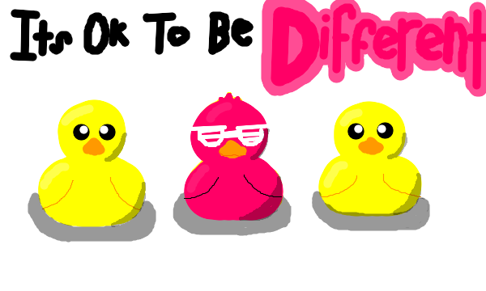

How are you the same as other 1st graders? | How are you different than other 1st graders?

